**FLOWCHART:**

* Flowchart A graphical representation of the logic for the problem solving.
* The purpose of the flowchart is making the logic of the program in a visual representation
* Flowcharts is a diagram made up of boxes, diamonds, and other shapes, connected by arrows.
* Each shape represents a step-in process and arrows show the order in which they occur.

|  |  |
| --- | --- |
|  | OVAL – TERMINAL SYMBOL |
|  | Parallelogram - Input/ Output symbol |
|  | Rectangle - Process symbol |
|  | Diamond - Decision symbol |
|  | Arrow lines - Flow lines |
|  | To represent a function |
|  | Circle - Connector |

**TOOLS USED TO DRAW FLOWCHART**

1. **Smart Draw –** A good tool to draw and understand but can’t save the file in system it can be used for free up to 7 days after that we must pay to use it.
2. **Canva –** A user-friendly tool which allows the user to view in mobile using the application and can be saved in any format. Without even subscription all the features were available.
3. **App.Diagrams.net -** The diagrams can be saved and also at any destination you want it to be. But the Output Wasn’t precise and not in single page the saved diagrams open up to the website.
4. **Lucidchart -** The diagrams can be directly stored into the system and has all the features and also easy to use. It is required to be paid after some uses .
5. **Visme –** The tool is used for flowchart animation and content creating and in teaching, but more tools are available when you pay for them.
6. **Zenflowchart –** The diagrams can be directly stored into the system and has all the features and also easy to use. But it restricts to use more than 20 shapes on using the

21st shape it must be paid.

1. **Visual Paradiagram –** Visual paradiagram is explicitly designed for flowchart drawing, it is also paid one to use but in complex algorithm cases it is the best
2. **Creatly –** This tool is used to design Unified Modeling Language (UML) and flowcharts.
3. **Google Draw –** All the features are available and they are directly stored in the Google Drive. It should be logged in using Email. But the page size was limited also typing the algorithm wasn’t comfortable.

**Exp No: 1- A**  **CALCULATING ELECTRIC BILL**

**Date: 29/ 11/22**

**AIM:**

To draw flowchart and write algorithm for calculating the electric bill.

**ALGORITHM:**

**STEP 1:** Start.

**STEP 2:** Enter Current Unit (CU). **STEP 3:** Enter Old Unit (OU).

**STEP 4:** Calculate N = CU - OU

**STEP 5:** Check for the condition N<=100 If true.

**5.1**: Calculate E.C using formula. FC = 0, DC = 0, EC= 0 **5.2:** Calculate the Total charges = FC + DC + EC

**5.3:** Display Total charges and go to Step 7.

**STEP 6:** Check for condition N<=200 If true.

**6.1**: Calculate E.C using formula FC = 20, DC = 18, EC = (N – 100) * 1.5 **6.2:** Calculate the Total charges = FC + DC + EC

**6.3:** Display Total charges and go to Step 7.

**STEP 7:** Check condition N<=500 of take.

**7.1:** Calculate EC using formula. FC = 73, DC = 48, EC = ( N - 100) * 3.5

**7.2:** Calculate the Total charges = FC + DC + EC

**7.3:** Display Total charges and go to Step 7.

**STEP 5:** Check for the condition N>500 If true.

**5.1:** Calculate the E.C using FC=75, DC=100, EC = (400 * 4.5) + (N - 500) * 6

**5.2:** Calculate Total charges = FC + DC + EC

**5.3:** Display the Total charges and go to Step 7. **STEP 7:** Stop.

**PSEUDO CODE:**

START

GET CU

GET OU

CALCULATE N=CU-OU IF N<=100 THEN

FC = 0, DC = 0, EC= 0

CALCULATE EC

ELIF N<=200 THEN

FC = 0, DC = 0, EC= 0 CALCULATE EC = (N – 100) * 1.5

ELIF N<=500 THEN

FC = 0, DC = 0, EC= 0 CALCULATE EC = ( N - 100) * 3.5

ELIF N>500 THEN

FC = 0, DC = 0, EC= 0

CALCULATE EC = (400 * 4.5) + (N - 500) * 6

ENDIF

PRINT Total Charges = FC + DC + EC

STOP

**FLOWCHART:**

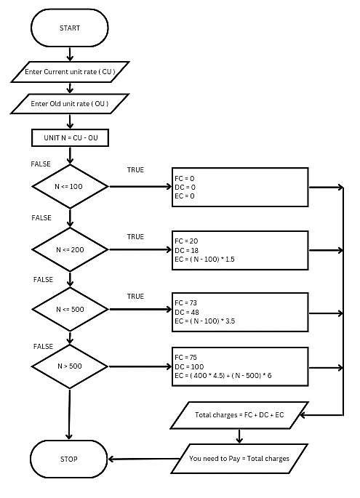

**RESULT:**

Thus, the algorithm and the flowchart is written for the given problem.

**Ex No : 1-B RELAIL SHOP**

**Date: 29.11.2022**

**AIM:**

To draw a flowchart and write an algorithm, flowchart and pseudo code for retail shop

**ALGORITHM:**

Step1: Start

Step2: Get the Bill No., details of the customer, date

Step3: Get the number of items purchased n

Step4: Initialise i=0, Gross=0, Net price=0

Step5: check for the condition i<n , if true go to step 5.1 else go to step 5.2

5.1: Get item name, item price and discount

5.1.1: Calculate Gross = n*item price

5.1.2: Calculate Discount amount =Gross*discount/100

5.1.3: Calculate Net price =Gross-Discount amount

5.1.4: Increament of I by 1

5.2: Get the value of GST

5.2.1: Calculate the GST amount = Net price*GST/100

5.2.2: Calculate Bill amount = Net price +GST amount

Step 6: Print Bill No, details of the customer ,Date, Bill Amount

**PSEUDO CODE:**

START

GET the Bill No., customer name, Ph no., Date

GET the number of items purchased as n

INITIALISE i=0, Net price=0, Gross =0

FOR i<n

GET item name, item price and discount

CALCULATE Gross = n*item price

Discount amount =Gross*Discount/100

Net price= Gross-discount amount

INCREAMENT i by 1

ELSE

GET the GST value

CALCULATE GST amount=Net price*GST value

Bill amount = Net price +GST Amount

PRINT Bill No., customer name, Ph no., Date, Bill amount

STOP

**FLOWCHART:**

No

Yes

Start

Get customer name, Ph

No., Bill No. and Date

Get the number of

items purchased n

Initialize i=0, Gross=0, Net price=0

If i<n

Get the item name, item

price, discount

Gross= n* item price

Discount amount=gross*discount/100

Net

price=subtotal

-

discount total

I=i+1

Get the value of

GST value

GST amount=Net price*GST/100

Bill amount = Net price + GST

amount

Print Customer

name,

stop

**RESULT:**

Thus the flowchart, algorithm and pseudo code is written for the given problem **Ex. No.:1-C WHEIGHT OF STEEL ROD**

**Date:29.11.2022**

**AIM:**

To draw a flow chart and write an algorithm for calculating weight of steel rod

**ALGORITHM:**

Step1: Start

Step2: Get the number if iron rods (n), diameter(D), length(L)

Step3: Initialize with i=0, total weight=0, unit weight=0

Step4: Check for condition i <=n

Step5: If yes, calculate unit weight =D^2L/162

5.1: Calculate total weight =n*D^2L/162

Step6: If the condition is false, display total weight of rod and stop.

**PSEUDOCODE:**

START

READ number of iron rods(n)

diameter(D) Length(X)

INITALISE i=1

Totalweight=0

Unitweight=0

FOR i<=n

CALCULATE Unit weight D2 L / 162

Total weight = n*( D2 L / 162 )

INCREAMENT i=i+1

ElSE

DISPLAY Total weight of rod

STOP

ROLL No: 22CSEB11 Name: KALYANI S **FLOW CHART**:

if

i<=n

unit

weight=D^2

L/162



Display

total

weight

of

rod



stop



Start



Read

number

of

iron

rods (n), diameter

D),Length(L

(

)



Initialize i=0,Total

weight=0,

Unit

weight =0

Total

weight

=

N*D^2L/162

I=i+1

**RESULT:**

Thus the flow chart and the algorithm is written for the given problem**.**

**Exp No: 1- D STUDENT GRADE ANALYSIS**

**Date: 29/ 11/22**

**AIM:**

To draw a flow chart and write and algorithm for student grade analysis.

**ALGORITHM:**

Step 1: Start

Step 2: Read the number of students n

Step 3: Check for the condition i<n

3.1: If yes go to step 4

3.2: If no, go to step 11

Step 4: Get student name, roll number, m1, m2, m3

Step 5: Calculate the percentage using the formula, m1+m23+m3/3*100

Step 6: Check for the condition, 90<percentage<=100

6.1: If yes, print name, roll number, “O+” and stop

6.2: If no, then go to the next condition.

Step 7: Check for the condition, 80<percentage<=90

7.1: If yes, print name, roll number, “O” and stop

7.2: If no, then go to the next condition

Step 8: Check for the condition, 70<percentage<=80

8.1: If yes, print name, roll number, “A” and stop

8.2: If no, then go to the next condition

Step 9: Check for the condition, 60<percentage<=70

9.1: If yes, print name, roll number, “B” and stop

9.2: If no, print name, roll number, “Fail” and stop

Step 10: Increment of i by 1

Step 11: stop

**PSEUDOCODE:**

START

READ number of students n

INITIALISE i=1

FOR i<=n

GET student name, roll no., m1, m2, ,3

CALCULATE percentage=m1+m2+m3/3*100

IF 90<percentage<=100

Print name, roll no., grade O+

ELIF 80<percentage<=90

Print name, roll no., grade O

ELIF 70<percentage<=80

Print name, roll no., grade A

ELIF 60<percentage<=70

Print name, roll no., grade B

ELSE

Print name, roll no., grade FAIL

END IF

INCREAMENT

ENDFOR

STOP

**FLOWCHART**

start

Read the number

of students n

Initialize i=1

If

90<

<=100

percentage

If 80<percentage<=90

If 70<percentage<=80

If 60<percentage<=70

Print name, roll no., grade FAIL

Print name, roll no., grade

O+

Print name, roll no., grade O

Print name, roll no., grade A

Print name, roll no., grade B

I=i+1

i<=1

Get student name, roll no,

m1, m2, m3

stop

**RESULT:**

Thus, the flowchart and the algorithm is written for the problem

**Exp No: 1- E CALCULATE WEIGHT OF A MOTORBIKE**

**Date: 29/ 11/22**

**AIM:**

To draw flowchart and write algorithm for calculating weight of a motorbike.

**ALGORITHM:**

Step 1**:** Start.

Step 2**:** Get gross vehicle weight Rating GVWR

Step 3**:** Get Dry weight (DW)

Step 4**:** Get Fuel weight (FW)

Step 5**:** Get Raider weight (RW)

Step 6**:** Get Passenger weight (PW)

Step 7**:** Calculate Total weight = DW+FW+RW+PW Step 8**:** Get Load.

Step 9**:** Calculate Load Weight = Total Weight + Load Step 10**:** Calculate Safe Weight = GVWR – Load Weight Step 11**:** Check the condition safe weight >=0.

11.1**:** If true, print the message “You have a safe load and you can drive" goto stop.

11.2**:** If false, print the message "Reduce the load and then drive”.

11.2.1**:** GOTO step 8.

STEP 12**:** Stop.

**PSEUDO CODE:**

START

GET GVWR

GET DW

GET FW

GET RW

GET PW

CALCULATE Total Weight = DW + FW+ RW + PW

GET Load

CALCULATE Load Weight = Total Weight + Load

CALCULATE Safe Weight = GVWR = Load Weight IF Safe Weight >= 0 Then

PRINT You have a safe load and you can drive ELSE

PRINT You have excess weight, Reduce the load and then drive

ENDIF

STOP

**FLOWCHART:**

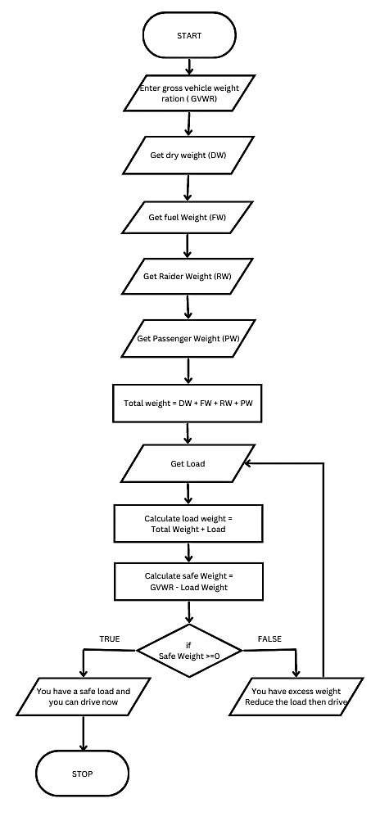

**RESULT:**

Thus, the flowchart and the algorithm is written for the problem.

**Exp No: 1- F SINE SERIES.**

**Date: 29/ 11/22**

**AIM:**

To draw a flow chart and write an algorithm for sine series.

**ALGORITHM:**

Step 1: Start

Step 2: Get the value of x, n

Where x must be in degree.

Step 3: Initialize i=1, s= -1**I, sine=0 and import math.

Step 4: Check for condition i<=n

4.1: If condition is true, convert x to radian using the formula

4.2: Then calculate sine series using the formula: Sine=sine +y**(2*i=1).factorial(2*i+1)*s

4.3: Increment of i by 1

Step 5: If condition is false, display sine and goto stop

**PSEUDOCODE:**

START

GET The value of x in degrees and n in nos.

INITIALISE i=1 , (-1)**I , sine=0 and import math

FOR i<n

CONVERT x to radianby y=x*π / 180

CALCULATE sine = y**(2*i+1). factorial(2*i+1)*s

INCREMENT I by 1

ELSE

PRINT sine

ENDFOR

STOP

**FLOW CHART**

if

i<=n

unit

weight=D^2L/16

2



Display

total

weight

of

rod



stop



Start



Read

number

of

iron

rods (n), diameter

)

D),Length(L

(



Initialize i=0,Total

weight=0,

Unit

weight =0

Total

weight

=

N*D^2L/162

I=i+1

**RESULT:**

Thus, the flowchart and the algorithm is writtn for the problem **Exp No: 1- G** **CALCULATE ELECTRICAL CURRENT IN 3 PHASR AC CIRCUIT**

**Date: 29.11.2022**

**AIM:**

To draw a flow chart and write an algorithm to calculate electrical current in 3 phase AC circuit

**ALGORITHM:**

Step1: Start

Step2: Read the values pf, I and V

Step3: Calculate P using the formula p=√3*pf*I*V

Step4: Print the value of P which is the electrical current in 3 phase AC circuit

**PSEUDOCODE:**

START

READ Pf, I, V

CALCULATE P= √ 3 * pf * I * v

PRINT The Result is P

ROLL No: 22CSEB11

Name: KALYANI S

**FLOW CHART:**



Start



Read

pf,

I,

V



Display

the

result

Is

P



Stop



Calculate

P=√3*pf*I*V

**RESULT:**

Algorithm and flowchart is written for the given problem

ROLL No: 22CSEB11

Name: KALYANI S